Facial Recognition

* Label: a specific class of data sample (e.g., a image of a face is labeled with an ID of the person)
* Training Data: labeled examples used by classifier to learn a task
* Test Data: data (separate from training data) used to evaluate classifier performance; a test label is compared with the classifier predicated label to evaluate classifier performance.
* Supervised Learning Method: a method that uses class labels of the training data to learn.
* Unsupervised Learning Method: a method that does not use the class labels of the training to learn.

Classifier - takes an input and produces an output

Ex: label face images as 1 or 0, and non-face classifier labels each image as 0 or 1.

Approaches to Face Matching

* Appearance-Based (pixel intensity)
  + Principal Component Analysis
  + Linear Discriminant Analysis
* Model-Based
  + Elastic Bunch Graph Matching
* Texture-Based
  + Local Binary Pattern (LBP)
* Deep Learning
  + Convolutional Neural Network

Principal Component Analysis

* Early automated face recognition method
* Goal: learn a subspace that accounts for as much variability in the training data as possible
* Does not use identity information during training (Unsupervised Learning)
* PCA Data Setup
  + Let x1, x2, …. Xn denote each training example
  + Compute the average of the training set
  + Define the matrix
  + Calculate the covariance matrix
  + Computer the Eigenvectors of the covariance matrix by solving where

E = [e1,e2,..ed] are the Eigenvectors

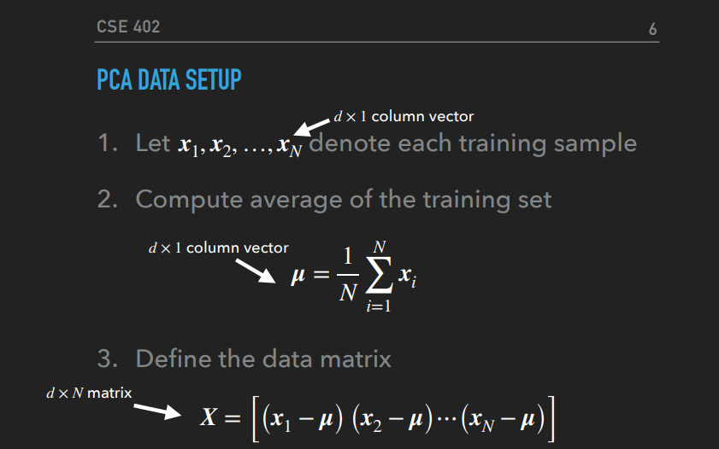

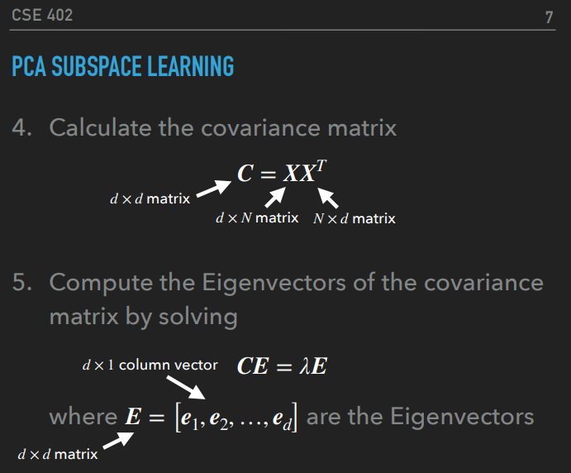

PCA Comparing Faces

* Instead of taking all “d” eigen-vectors, Ek takes the top “k” eigen-vectors(eigner-vectors are arranged in columns)
* 1. Represent two unseen images, and , as a weighted sum of Eigenvectors
* 2. Compare difference of weighted sums to threshold (t)
  + Faces are considered a match if the difference is less than the threshold, otherwise they are not a match

